WELCOME TO CamMUN 8-10.3.2019
Stephen Perse Foundation (Main Office) Union Road, Cambridge CB2 1HF
Get directions and parking advice tel: 01223 454700 email: office@stephenperse.com
CamMUN Advisers: Dr Ulrike Walton-Jordan: uwj@stephenperse.com; Dr Sonya Kirk: srk@stephenperse.com
 @SPFschools
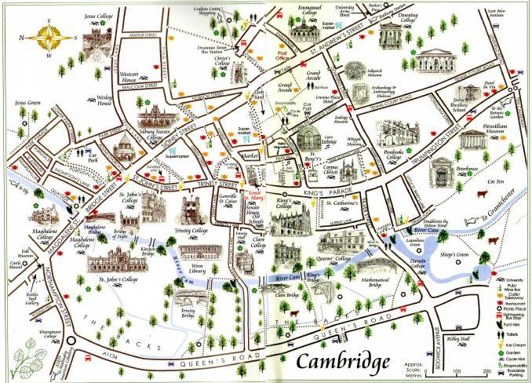
HINTS AND TIPS FOR DELEGATION ADVISERS

We would like to remind all visiting colleagues that we will welcome you and your group in the greatest spirit of professional co-operation, but that you retain responsibility for the safety, wellbeing and behaviour of your students during the entire CamMUN2019 conference, including the Social Event on Saturday evening. Whilst on SPF premises, we will expect them to follow the rules and regulations as set out by the CamMUN Secretariat and SPF staff on duty. In keeping with professional standards, we would expect you to make sure that your students are accounted for at all times, be it at the conference or moving around Cambridge and between school sites. We would appreciate an up-to date list of mobile phones for emergencies, please, by email to cammun@stephenperse.com.

PLANNING YOUR FREE TIME

FREE Official Visitor App
If you're planning a visit to Cambridge or if you're already on your way, then you'll need our FREE Official Visitor App to help you plan your journey and help you navigate your way around the city when you arrive.
The app is available to download from the Play Store and App Store!


WALKING TOURS
https://footprints-tours.com/cambridge-city-university-walking-tour/
EATING OUT
https://www.tripadvisor.co.uk/Restaurants-g186225-Cambridge_Cambridgeshire_England.ht
MUSIC
https://www.anglia.ac.uk/arts-law-and-social-sciences/mumford-theatre/ltc-spring2018-09march
King’s College Chapel 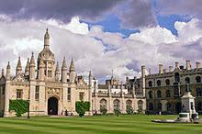
CHORAL SERVICES MARCH 2019
9 Saturday Vigil of Lent 1
5.30 Evensong
INTROIT Wie wunderbarlich ist doch diese Strafe
(Heermann) Bach
ANTHEM 180 Jehovah, quam multi sunt hostes Purcell
VOLUNTARY Prelude and Fugue in E minor BWV 548 Bach
6.40 Organ recital given by Rashaan Allwood
10 Sunday First Sunday in Lent
10.30 Holy Eucharist
MASS Missa ‘Papæ Marcelli’ Palestrina
VOLUNTARY Passacaglia in D minor BuxWV 161 Buxtehude
3.30 Evensong
PRELUDE Three Organ Voluntaries Maxwell Davies
CANTICLES Stanford in B flat
ANTHEM Crucifixus pro nobis (Carey, Fletcher) Leighton
VOLUNTARY Aus tiefer Not schrei’ ich zu dir BWV 686 Bach
PUNTING
https://www.scudamores.com/punting-quayside

